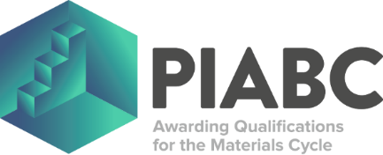

ST0659 MATERIALS PROCESS ENGINEER (DEGREE)
AM1: WORK-BASED PROJECT AND PRESENTATION OUTLINE

To ensure that the apprentice’s work-based project is suitable for the ST0659 Materials Process Engineer (Degree) End Point Assessment (EPA) the project’s subject, title and scope needs to be approved by both the employer and PIABC Limited at the gateway. The apprentice needs to complete this template so that the employer and PIABC Limited can ensure that the apprentice’s project has a real business application and meets the requirements of the EPA (including suitable coverage of the KSBs assigned to this assessment method).

APPRENTICE DETAILS
Name:
Unique Learner Number (ULN):
Date:

PROJECT OUTLINE DETAILS
Project Title:
Project Subject:
Project Scope:

The apprentice is advised to have read “ST0659 - AM1 - Work-Based Project Guidance” before completing this template as it lists all the Knowledge, Skills and Behaviours (KSBs) that are being assessed by this assessment method along with detailed assessment criteria and full grading descriptors. These KSBs, detailed assessment criteria and full grading descriptors will guide the apprentice on what they need to evidence to successfully pass this assessment method, which comprises of a project report and presentation with questioning.

