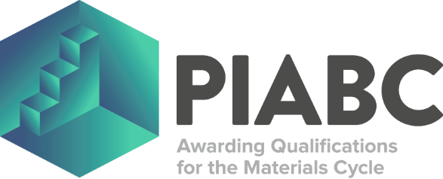

ST0659 MATERIALS PROCESS ENGINEER (DEGREE)
PROJECT OUTLINE DECLARATION FORM

The apprentice’s work-based project needs to be designed to ensure that it meets the needs of the employer’s business, is relevant to their role and allows the relevant KSBs to be demonstrated for their End Point Assessment (EPA). It is the role of the employer to ensure that the project has a real business application and PIABC Limited to ensure that it meets the requirements of the EPA (including suitable coverage of the KSBs assigned to Assessment Method 1). To ensure that the apprentice’s work-based project is suitable for the ST0659 Materials Process Engineer (Degree) EPA then the apprentice’s project’s subject, title and scope needs to be agreed between the employer and PIABC Limited at the gateway using this declaration form.

To be completed by the Employer:

APPRENTICE DETAILS
First Name: |  | Last Name:
Unique Learner Number (ULN): |  | Date of Birth:

EMPLOYER DECLARATION
I confirm on behalf of the apprentice’s employer that the apprentice’s project has a real business application and is suitable as a work-based project for the ST0659 Materials Process Engineer (Degree) EPA.
Name: |  | Signature:
Job Title: |  | Date:
Organisation Name:
Address:
Postcode: |  | Email address:

To be completed by PIABC Limited:

PIABC LIMITED DECLARATION
I confirm on behalf of PIABC Limited that the apprentice’s project meets the requirements of the EPA (including suitable coverage of the KSBs assigned to Assessment Method 1) and is suitable as a work-based project for the ST0659 Materials Process Engineer (Degree) EPA.
Name: |  | Signature:
Job Title: |  | Date:

This Project Outline Declaration Form should be returned by email (piabc@iom3.org) to the EPA Team for PIABC Limited to complete and upload on ACE360.

